Ideation Phase
Empathize & Discover

Date | 7 NOVEMBER 2O25v
Team ID | NM2025TMID06700
Project Name | Medical Inventory Management
Maximum Marks | 4 Marks

Empathy Map Canvas:

The Empathy Map for the Medical Inventory Management System focuses on understanding the challenges faced by hospital administrators, pharmacists, and medical staff in managing medical supplies. These users struggle with manual tracking, inaccurate records, and frequent stockouts or expired medicines. They often express frustration about time-consuming stock checks and delayed reordering processes.

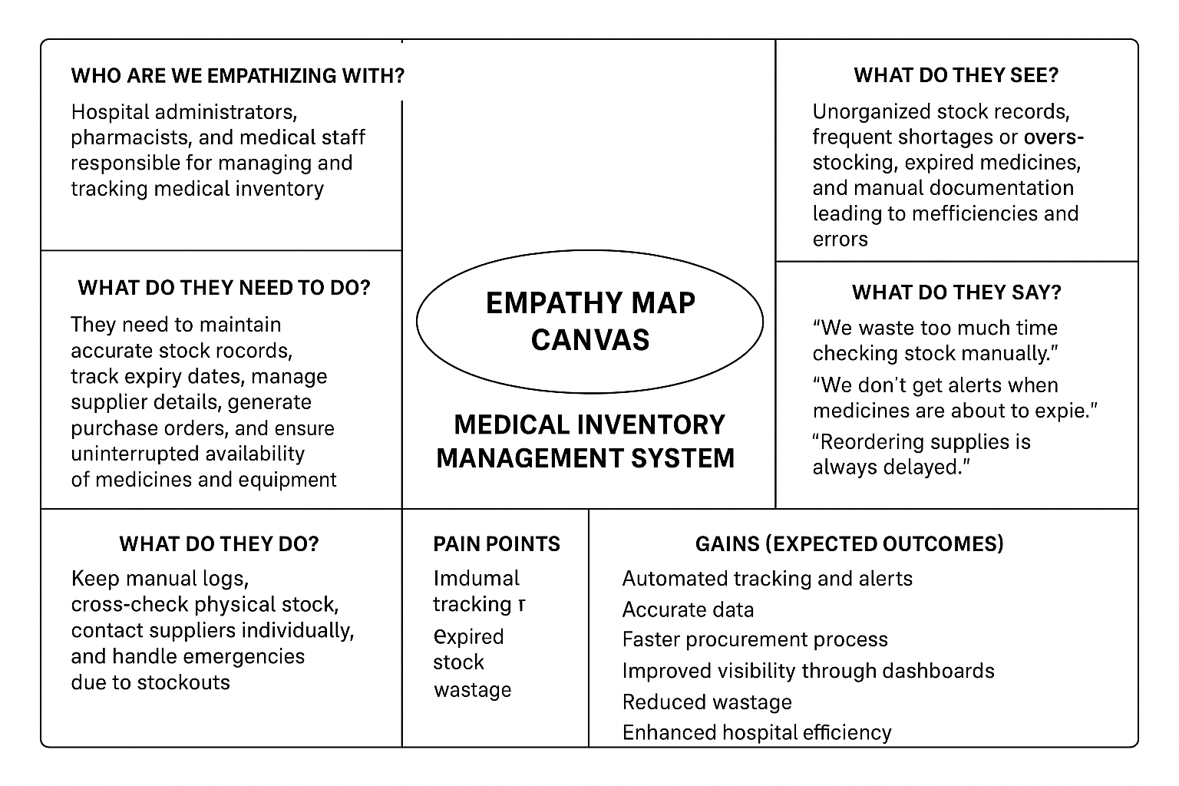

Example:

Medical Inventory Application and Developement

